**Properties and Definitions**

**Useful constants, properties, and conversions**

gc = 32.2 ft/sec2 [lbm-ft/lbf-sec2]

ρwater = 1.96 slugs/ft3

γwater = 62.4 lb/ft3

1 ft3/sec = 449 gpm

1 mgd = 1.547 ft3/sec

1 foot of water = 0.433 psi

1 psi = 2.31 ft of water

**Definitions**

**discharge:**  flow rate, usually in ft3/sec or gpm

**Properties**

**Density**

Density (ρ) is mass per unit volume (slugs/ft3)

**Specific Weight (aka Unit Weight)**

Specific Weight (γ) is weight per unit volume (lb/ft3) = ρg

**Specific Gravity**

Specific Gravity (S) is the ratio of the weight (or mass) or a substance to the weight (or mass) of water.

ormula

where the subscript "s" denotes of a given substance and the subscript "w" denotes of water.

Given S of a substance, you can easily calculate ρ and γ using the equations

ormula

ormula

**Specific Volume**

Specific Volume is the volume per unit mass (usually in ft3/lbm)

**Viscosity**

Viscosity (υ) is a measure of a fluid's ability to resist shearing force (usually in lbf·sec/ft2)

υ is a proportionality constant and is also known as absolute viscosity or dynamic viscosity.

Viscosity is often given in the SI unit of Poise.  To convert to English units use the relationship

ormula

**Kinematic Viscosity**

ormula

where

γ = kinematic viscosity (ft2/s)

υ = dynamic viscosity (lbf·sec/ft2)

ρ = mass density (slugs/ft3)

Note:  See CERM Appendix 14.A (page A-13) for a listing of water properties at various temperatures.

**Absolute and Gauge Pressure**

Absolute Pressure (psia) = Atmospheric Pressure + Gauge Pressure (psig)

Atmospheric Pressure changes with weather conditions and altitude though is usually assumed to be 14.7 psi at sea level.

Pressures are usually given in psig, except for compressible flow.

**Fluid Statics**

**Fluid Pressure**

Liquids can be assumed to have constant density over fairly large vertical distances.  The same can be said of gases although only over small distances.  Given that the pressure of the fluid body is zero at its surface, the pressure at any point below the surface is easily calculated as

ormula

where

p = pressure (lb/ft2)

γ = specific weight of the fluid (lb/ft3)

h = height of water above point (ft)

ormula

**Forces on Submerged Planar Surfaces**

The resultant force of fluid on a submerged planar surface is defined by its magnitude, direction, and location as shown on the following summary diagram:

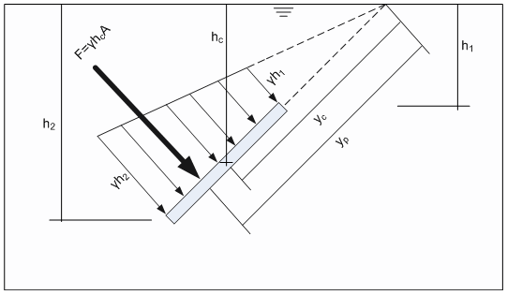

**Direction**

For planar surfaces in a fluid, the pressure direction is always normal to the surface it contacts.

**Magnitude**

The magnitude of the force acting on the planar surface is the volume under the pressure prism:  the product of the pressure at its centroid and the area of the plane.

ormula

where

γ = specific weight of the fluid (lb/ft3)

hc = height of water above the *centroid of area* of the planar surface (ft)

A = area of the planar surface (ft2)

**Location**

The location of the force acting on a planar surface is the center of gravity of the pressure prism and is also called the center of pressure (yp).

ormula

ormula

ormula

where

yp = distance from origin to center of pressure (ft)

yc = distance from origin to centroid of area (ft)

Io = moment of inertia

Icg = moment of inertia about the centroid

|  |
| --- |
| Moments of Inertia about the Centroid for Basic Shapes |
|  |
|  |

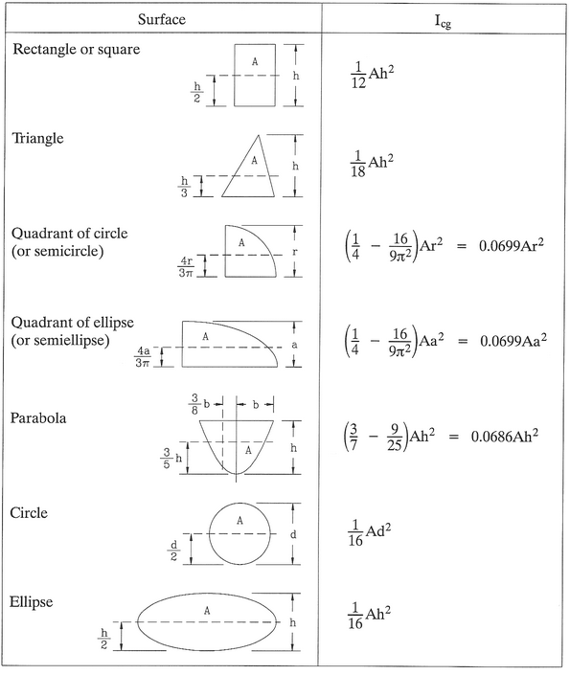

Use of the above table for Icg simplifies the calculation of yp because the A terms will cancel.

**Fluid Dynamics**

**Continuity Equation**

The continuity equation states that the mass flow rate is constant at steady state:

ormula

where

ρ = mass density (slugs/ft3)

A = cross-sectional area of the flow(ft2)

V = velocity of the flow (ft/sec)

Because liquids can be assumed to have constant density over fairly large vertical distances, the continuity equation simplifies to

ormula

where

Q = discharge (ft3/sec)

A = cross-sectional area of the flow (ft2)

V = velocity of the flow (ft/sec)

**Energy Equation**

The energy equation requires that the energy between two points may change form but the total is always conserved:

ormula

or

ormula

The energy in the fluid at point 1 and 2 is the total of pressure, kinetic, potential, and internal energy. The energy added from point 1 to 2 is heat and mechanical energy.  The energy lost from point 1 to 2 is called "head loss" (hL).

The energy equation is simplified in the case of fluids where the temperature doesn't change (I1 = I2) , no heat is added (eh=0), and the only mechanical energy added is by a pump (em is replaced with hp):

ormula

where

P/γ = pressue head (ft)

v2/2g = kinetic head (ft)

Z = potential head (ft)

hp = head of the pump (ft)

hL = head loss (ft)

***Note:***  It is almost always simplest to treat all the heads in feet even though pressure heads, pump heads, and head losses are sometimes be given in psi.

The energy equation is greater simplified in the case of fluids where the temperature doesn't change (I1 = I2), no heat is added (eh=0), no pump is involved (em=0, and losses are small (hL=0).  In such cases, the simplified energy equation is know as Bernoulli's Theorem which says that between any two points, the total of the pressure, kinetic, and potential energy is equal:

ormula

and more generally

ormula

[Include Potential Energy = mgH = WH = γ·volume x H ?]

**Fluid Flow through Pipes**

The most important aspect of fluid flow through pipes is the evaluation of friction head loss (often referred to as hf instead of hL) which is the conversion of energy per unit weight into nonrecoverable form energy.  There are three commonly used relationships for determining hf due to the flow of fluid through pipes:  the Darcy-Weisbach equation, the Hazen-Williams equation, and the Manning equation.  The Hazen-Williams and Manning equations are also used in determining velocity and flow given pipe characteristics and the hydraulic gradient.

**Reynolds Number**

The Reynolds Number (Re) is dimensionless number that describes the flow of fluid.  It is the ratio of inertial forces to viscous forces.

ormula

where

V = average velocity (ft/sec)

D = inside pipe diameter (ft)

γ = kinematic viscosity (ft2/s)

υ = dynamic viscosity (lbf·sec/ft2)

ρ = mass density (slugs/ft3)

**Laminar Flow**

Laminar flow exists when the fluid particles move along in smooth paths.  The average velocity of such flow is relatively low and doesn't often occur in engineering applications.  Laminar flow occurs when Re<2000 and in such cases, the friction factor is only a function of Re.  The energy head lost is a result of the fluid viscosity and friction loss varies with the velocity.

**Transitional Flow**

Transitional flow occurs in a critical zone where the average velocity changes the flow form laminar to turbulent.  Transitional flow occurs when 2000<Re<4000.

**Turbulent Flow**

Turbulent flow exists when the fluid particles move in very irregular paths.  The energy head lost is a result of the turbulence and friction loss varies with square of the velocity.

**Darcy-Weisbach Equation**

ormula

where

hf = friction head loss (ft)

f = friction factor

L = length of pipe (ft)

D = diameter of pipe (ft)

V = velocity (ft/sec)

**Friction Factor**

The Darcy friction factor (f) is a function of the fluid properties and pipe material.  In general

ormula

where

e = size of surface imperfections

D = diameter of pipe

e/D = relative roughness of the pipe

**Moody Diagram**

The most common method of determing the friction factor is by the use of the Moody Diagram.

|  |
| --- |
| Moody Diagram for Finding f Given Re and e/D |
|  |

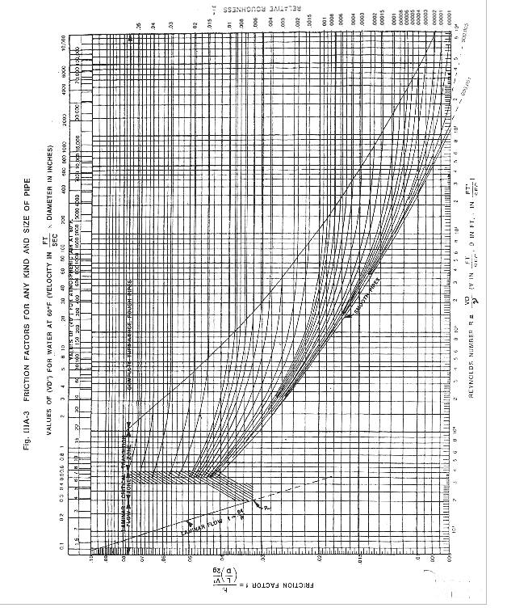

To use the Moody diagram to find the friction factor, choose the curve for a specific relative roughness.  Follow the curve (you'll be starting from the right) and stop when you get directly above the Reynolds Number (shown on the bottom) or direcly below VD (shown on the top and only applicable if the water temperature is 60F).  Go straight to the left axis and the value read is the appropriate friction factor.

**Table**

Tables are another common method of finding the friction factor.  The CERM Appendix 17.B (starting on page A-27) lists friction factors for various Re and e/D.

**Nonograph**

**Equation**

The friction factor can also be determined by equation depending on condition of the flow as shown in the following table.

|  |  |  |
| --- | --- | --- |
| Type of Flow | Range of Application | Equation for f |
| Laminar | Re < 2100 |  |
| Smooth Pipe and Turbulent flow | 3000 < Re < 100,000 |  |
| Smooth Pipe and extra Turbulent flow: Karman-Nikuradse equation | Re > 100,000 |  |
| Rough Pipe and Turbulent flow | Re > 4000 |  |
|  |  |  |

For fully turbulent flow, the Swamee-Jain equation can be used to solve for the friction factor

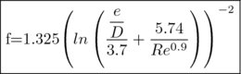

**Hydraulic Radius**

ormula

where

wetted perimeter = perimeter where water touches a solid surface

**Hazen-Williams Formula**

ormula

where

V = velocity (ft/sec)

C = Hazen-Williams Coefficient

R = hydraulic radius (ft)

S = slope of hydraulic gradient (ft/ft)

|  |  |
| --- | --- |
| Hazen-Williams Coefficient (C) | |
| Asbestos Cement | 140 |
| Brass | 130-140 |
| Brick Sewer | 100 |
| Cast Iron, New, Unlined | 130 |
| Cast Iron, Old, Unlined | 40-120 |
| Cast Iron, Cement Lined | 130-150 |
| Cast Iron, Mitumastic | 140-150 |
| Enamel Lined, Tar-coated | 115-135 |
| Concrete or Concrete Lined, Steel Forms | 140 |
| Concrete or Concrete Lined, Wooden Forms | 120 |
| Concrete or Concrete Lined, Centrifugally Spun | 135 |
| Copper | 130-140 |
| Fire Hose, Rubber Lined | 135 |
| Gavlanized Iron | 120 |
| Glass | 140 |
| Lead | 130-140 |
| Plastic | 140-150 |
| Steel, Coal-tar Enamel Lined | 150-154 |
| Steel, New, Unlined | 140-150 |
| Steel, Riveted | 110 |
| Tin | 130 |
| Vitrified Clay | 100-140 |

**Hazen-Williams formula, Circular Pipes**

ormula

where

D = diameter of pipe (ft)

The Hazen-Williams formula is easily modified to solve for flow

ormula

where

Q = discharge (ft3/sec)

ormula

where

Q = dischare (mgd)

ormula

where

Q = discharge (gpm)

d = diameter of pipe (in)

The Hazen-Williams formula is also useful for calculating friction head loss:

ormula

where

hf = friction head loss (ft)

L = length of pipe (ft)

Q = discharge (ft3/sec)

C = Hazen-Williams Coefficient

D = diameter of pipe (ft)

**Manning Equation, Circular Pipes**

Although the Manning Equation is most often used for calculating flow in open channels, it can also be used to calculate flow in pipes.

ormula

where

A = cross-sectional flow area (ft2)

R = hydraulic radius (ft)

S = slope of energy grade line or slope of channel bed for uniform flow

n = manning roughness factor (see [Table of Manning's Roughness Coefficients](https://civilengineers-penotes.pbworks.com/ManningsRoughnessCoefficients))

**Head Loss**

ormula

hf = friction head loss (ft)

n = Manning roughness coefficient

L = length of pipe (ft)

Q = discharge (ft3/sec)

D = diameter of pipe (ft)

**Minor Losses**

Although the greatest cause of head loss (pressure drop) of fluid flow in a pipe is friction, there are other losses that result from abrupt changes to the flow at entrances, valves, fitting, bends, and exits.  These losses are are minor if the length of pipe is long (and therefore hf is high) but they must be considered especially when the length of the pipe is short.  There are two primary methods of calculation these minor losses:  velocity head and equivalent length.

**Velocity Head, Circular Pipes**

The velocity head method adds a term for minor losses in hL

ormula

where

k = coefficient

V = velocity of flow (ft/sec)

**Equivalent Length, Circular Pipes**

The equivalent length adds an appropriate distance (Leq) to the actual length of pipe to account for the minor losses.

ormula

where

k = coefficient

D = diameter of pipe (ft)

f = friction factor

**Loss Coefficient (k)**

|  |  |
| --- | --- |
| Globe valve (fully open) | 6.4 |
| Globe valve (half open) | 9.5 |
| Angle valve (fully open) | 5.0 |
| Swing check valve (fully open) | 2.5 |
| Gate valve (fully open) | 0.2 |
| Gate valve (half open) | 5.6 |
| Gate valve (one-quarter open) | 24.0 |
| Close return bend | 2.2 |
| Standard tee | 1.8 |
| Standard elbow | 0.9 |
| Medium sweep elbow | 0.7 |
| Long sweep elbow | 0.6 |
| 45 degree elbow | 0.4 |
| Square-edged entrance | 0.5 |
| Reentrant entrance | 0.8 |
| Well-rounded entrance | 0.03 |
| Pipe exit | 1.0 |
| Sudden contraction (2 to 1) | 0.25 |
| Sudden contraction (5 to 1) | 0.41 |
| Sudden contraction (10 to 1) | 0.46 |
| Orifice plate (1.5 to 1) | 0.85 |
| Orifice plate (2 to 1) | 3.4 |
| Orifice plate (4 to 1) | 29.0 |
| Sudden enlargement | (1-A1/A2)2 |
| 90 degree miter bend (without vanes) | 1.1 |
| 90 degree miter bend (with vanes) | 0.2 |
| General contraction (30 degree included angle) | 0.02 |
| General contraction (70 degree included angle) | 0.07 |
| Notes:  (x to 1) is the area ratio, sudden enlargement is based on V1, and well-rounded entrance and sudden contractions are based on V2. | |

The equivalent length can also be read directly from a table such as CERM Appendix 17.D

**Equivalent Length, Non-Circular Pipes**

In the case of con-circular pipes, the equivalent length equation requires the use of equivalent diameter in the place of diameter

ormula

where

k = coefficient

Deq = equivalent diameter of pipe (ft)

f = friction factor

ormula

**Relationship between Velocity Head and Equivalent Length**

The velocity head and equivalent length methods are related by the equation

ormula

**Pipes in Series**

**Pipes in Parallel**

**Branching of Pipe**

**Pumps**

**Power Considerations**

The work, measured in horsepower, done by a pump is related to the pump head (hp) through the equation

ormula

where

HP = work done by the pump (hp)

γ = specific weight of the fluid (lb/ft3) = 62.4 lb/ft3 for water

hp = head of pump (ft)

Q = discharge (ft3/sec)

**Cavitation in Pumps**

As a pump's impeller blades move through a fluid, low pressure areas are formed as the fluid accelerates around and moves past the blades. The faster the blades move, the lower the pressure around it can become.  As it reaches vapor pressure, the fluid vaporizes and forms small bubble of gas.  This is cavitation.  When the bubbles collapse later, they typically cause very strong local shockwaves in the fluid, which may be audible and may even damage the blades.  Cavitation in pumps may occur in two different forms:  suction cavitation and discharge cavitation

**Suction cavitation**

Suction cavitation occurs when the pump suction is under a low pressure/high vacuum condition where the liquid turns into a vapor at the eye of the pump impeller. This vapor is carried over to the discharge side of the pump where it no longer sees vacuum and is compressed back into a liquid by the discharge pressure. This imploding action occurs violently and attacks the face of the impeller. An impeller that has been operating under a suction cavitation condition has large chunks of material removed from its face causing premature failure of the pump.

**Discharge cavitation**

Discharge cavitation occurs when the pump discharge pressure is extremely high, normally occurring in a pump that is running at less than 10% of its best efficiency point. The high discharge pressure causes the majority of the fluid to circulate inside the pump instead of being allowed to flow out the discharge. As the liquid flows around the impeller it must pass through the small clearance between the impeller and the pump cutwater at extremely high velocity. This velocity causes a vacuum to develop at the cutwater (similar to what occurs in a venturi) which turns the liquid into a vapor. A pump that has been operating under these conditions shows premature wear of the impeller vane tips and the pump cutwater. In addition, due to the high pressure conditions, premature failure of the pump's mechanical seal and bearings can be expected. Under extreme conditions, this can break the impeller shaft.

**Net Positive Suction Head Available (NPSHA)**

Cavitation is avoided by ensuring there is sufficient net positive suction head available to keep the fluid pressure above the vapor pressure.  The energy equation can be used to calculate NPSHA.  Based on conditions at the top of an open fluid source (e.g. tank or reservoir) where there is no kinetic energy:

ormula

where

NPSHA = Net Positive Suction Head Available (ft)

hatm = atmospheric head (ft)

hz(s) = static suction head (ft)

hf(s) = friction suction head (ft)

hvp = vapor pressure head (ft)

Atmospheric head can be found using the equation for fluid pressure: p (psi) = specific wt. (lb/ft3) * hatm (ft) / 144 (in2/ft2).  Static suction head is given by the piping geometry.  The friction head is often found by using the Hazen-Williams formula or a Moody diagram.  Vapor pressure head is listed in CERM appendix 14.A.

Based on the conditions at the immediate entrance to the pump, there is both potential and kinetic head loss (and so there are terms for static (pressure) head and velocity head at the pump suction). In this second case, the reduced pressure head already accounts for the friction losses and the atmospheric head.

[Insert equation?]

**Open Channel Flow**

Uniform flow in open channels is often calculated using the Chezy formula and it's derivate, the Manning formula.

**Definitions**

**normal depth**:  the only one uniform depth for a discharge in a given channel with a given slope

**critical depth**:  the depth at which for a certain flow, the specific energy is a minimum

**open channel flow**: the flow of water as a free surface by gravity (not pressure)

**uniform flow**:  flow in which the depth and velocity doesn't change along a channel

**The Chezy Formula**

ormula

where

V = velocity (ft/sec)

C = Chezy's frictional coefficient (aka coefficient of rugosity)

R = hydraulic radius (ft)

S = slope of channel bed

C has been empirically calculated by Manning and Darcy-Weisbach.

**C By Manning**

ormula

where

R = hydraulic radius (ft)

n = Manning's roughness coefficient

**C By Darcy-Weisbach**

ormula

where

f = Darcy-Wiesbach friction coefficient

**The Manning Formula**

ormula

where

Q = discharge (ft3/sec)

A = cross-sectional flow area (sqft)

R = hydraulic radius (ft)

S = slope of energy grade line or slope of channel bed for uniform flow

n = Manning's roughness coefficient

Manning's roughness coefficient is affected by many factors, including surface roughness, vegetation, channel irregularity, channel alignment, scouring, and silting.  See [Table of Manning's Roughness Coefficients](https://civilengineers-penotes.pbworks.com/ManningsRoughnessCoefficients) for a listing of coefficients.

**By Tables**

Open channel flow for symmetrical rectangular, trapezoidal, and v-notch channels can easily be read from tables.  See CERM Appendix 19.E (page A-41) for conveyance factors Q given bottom width or depth.

**Energy**

**Specific Energy**

ormula

where

e = energy per unit weight with elevation datum taken as the bottom of channel

y = water depth (ft)

V = velocity (ft/sec)

ormula

**Critical Depth**

**Froude Number**

ormula

where

V = velocity (fps)

y = water depth (ft)

if F=1, flow is *critical*

if F<1, flow is *subcritical* or *tranquil*

if F>1, flow is *supercritical* or *shooting*

**Critical depth, wide rectangular channel**

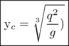

where

q = discharge per unit width (cfs/ft)

**Critical depth, circular channel**

The critical depth of a circular channel given discharge can be easily read from curves.  See CERM Appendix 19.D (page A-40) for critical depth curves for various pipe diameters given discharge.

**Hydraulic jump**

If flow before the jump is supercritical, a jump will occur and flow after the jump will be subcritical.  The jump destroys excess energy (velocity).

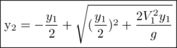

where

y2 = depth after the jump (ft)

y1 = depth before the jump (ft)

V1 = velocity before the jump (fps)

y2 and y1 are called *conjugate depths*

ormula

where

hL = head loss in the jump (ft)

ormula

where

HP = energy dissipated by the jump (hp)

**Circular Sections not Flowing Full**

Pipes not flowing full can be treated like an open channel.

See CERM Appendix 19.C (page A-39) for circular channel ratios that can be used to read velocity and discharge ratios as well as area and wetted perimteter for various n and f assumptions

**Depth Curves**

|  |
| --- |
|  |

|  |
| --- |
| Critical Depth Curbe Given Q |
|  |

|  |
| --- |
| Normal Depth Curve Given Q |
|  |

**Weirs**

Weirs are structures consisting of an obstruction across an open channel usually with a specially shaped opening or notch. The weir results in an increase in the water level which is measured upstream of the structure. This increase in water level can be the desired effect, the weir can be used to calculate the flow rate as a function of the head on the weir (this is the most common use of weirs), or the weir can be used to control the release of water. Most weirs are plates (exceptions include the broad-crested weir) or concrete (spillways).

Spillways, a subset of weirs, are structures consisting of an obstruction across an open channel or body of water that are designed to control the release of water. Spillways are usually concrete and attempt to reduce water separation by taking a form that matches the underside of the nappe.  Broad-crested weirs can function as spillways except their form doesn't match the underside of the nappe (like ogee spillways).

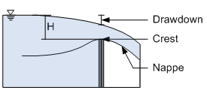

**Definitions**

**nappe**:  the water that falls over a weir

**contraction:**  the decrease in width of the nappe as it falls over the weir; sometimes used to refer to a weir that causes the contraction (i.e. contracted weir)

**suppressed**:  when the weir extends the full width of the channel, the contractions are suppressed; used to refer to the weir

**Rectangular Weirs**

Theoretical flow over a rectangular weir is calculated as:

ormula

where

Q = discharge (cfs);

C = weir coefficient;

b = width of weir (ft)

g = acceleration due to gravity (32.2 ft/sec2)

H = head on weir above weir crest (ft)

h = velocity head upstream of weir (ft)

Remember, velocity head (ft) is calculated as

ormula

where

v = velocity (fps)

The Francis formula is used to calculate flow over a weir:

ormula

where

n = number of contractions

Approach velocity is often negligible (or can be assumed zero and then solved iteratively).  In such cases, if the rectangular weir is fully contracted, then the discharge can be calculated as

ormula

and if the rectangular weir is fully suppressed, then the discharge can be calculated as

ormula

Warning:  If the nappe is not ventilated, the water will not jump free on the crest to create a bottom contraction.  In this case, the discharge will be greater than calculated.

**Triangular Weirs**

The triangular weir has a V-notch opening and is often used for low flow measurements where a rectangular weir wouldn't allow the nappe to spring clear.  The theoretical formula is

ormula

where

θ =  vertex angle (degrees)

C = weir coefficient which depends on head and θ.  For θ=90°, C=0.59

**Trepezoidal Weirs**

Many configurations of trapezoidal weirs are used, but the most common is the Cipolletti Weir which was a side slope of 0.25 (1/4 horizontal to one vertical) which increases the flow over that of a rectangular weir of the same width.  This has the effect of offsetting the decrease in discharge from the end contractions and the formula for flow is

ormula

**Spillways**

The equation for flow over spillways is similar to that of a rectangular weir

ormula

where

L = effective length of the crest (ft)

C = discharge coefficient which ranges from 3.0 to 4.1 and depends on the ratio of design head to height of spillway.  For ogee spillways, C varies from 3.3 to 3.98 (use 3.97 for a first approximation).  For broad-crested weirs, C varies from 2.63 to 3.33 (use 3.33 for a first approximation).